Community Organizations’ Roles in Supporting Policy and Campaign Implementation for Tobacco Cessation
The Motivation for this Work  Around the world, smoking kills an estimated 7 million people each year. Of those deaths, 6 million are due to the direct effects of smoking while approximately 1 million deaths are the result of second-hand smoke exposure. Among the many policy changes that can support tobacco control, Graphic Health Warnings (GHWs) on cigarette packages have been shown to help in both the prevention and cessation of tobacco consumption.  Community organizations can provide important supports for GHWs as government and policy officials implement the labels and other tobacco control policies. These supports might include providing wrap-around education, engaging in advocacy, or connecting diverse partners to increase the impact of GHWs. Yet, such strategic involvement is not always included when implementation plans are created. A recent study from the Dana-Farber Cancer Institute and Harvard T.H. Chan School of Public Health explored what it means for local organizations to support the implementation of GHWs for tobacco cessation, with an emphasis on the barriers to and facilitators of such supports.  https://www.who.int/news-room/fact-sheets/detail/tobacco |  | What are Graphic Health Warnings?  Graphic health warnings (GHWs) are labels that cover a large portion of the front of cigarette package with information and images about the risks of smoking and tobacco use. GHWs have been shown to:  - attract smokers’ attention  - increase awareness of smoking-related health risks,  - decrease cigarette consumption  - motivate cessation attempts  - increase the use of cessation services, and  - increase smoking abstinence.  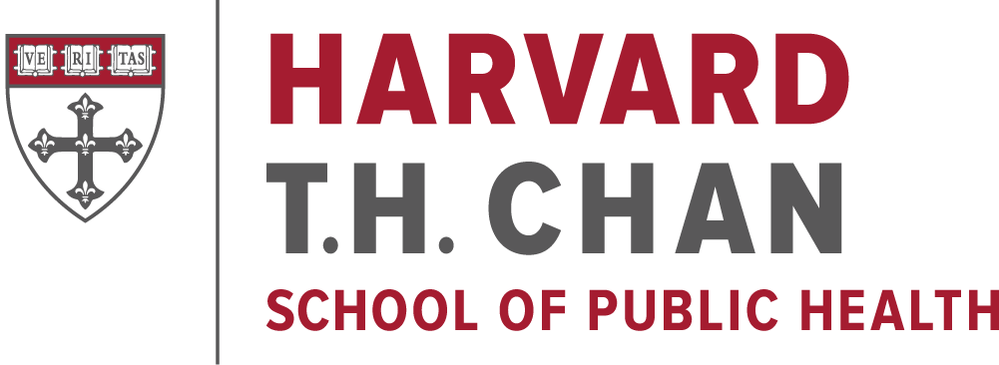
Source Publication: Shoba Ramanadhan, ScD, MPH; Rebekah H. Nagler, Ph.D.; Jaclyn M. Alexander-Molloy, MPH; K. “Vish” Viswanath, Ph.D. Local Organizations Supporting Implementation of Graphic Health Warnings of Tobacco in Underserved Communities: A Qualitative Inquiry Frontiers in Public Health, 6(322). Available at no charge at https://www.frontiersin.org/articles/10.3389/fpubh.2018.00322/full

About the Study |  |  | Key Findings
From 2014 to 2015, researchers conducted 20 interviews with community leaders in the cities of Boston, Lawrence, and Worcester, MA to understand how community organizations can contribute to the implementation of graphic health warnings for tobacco cessation and prevention in their communities. Participants represented a range of sectors including community, healthcare, and government.  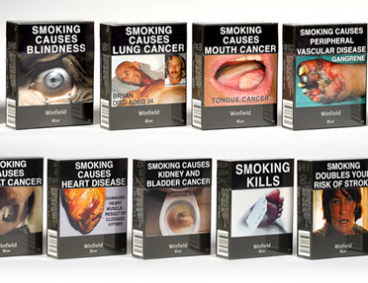  Figure 1: Example of GHWs on cigarette packages in Australia |  |  | - Participants highlighted a wide range of supporting roles for the implementation of GHWs and policy to support tobacco cessation and prevention efforts in their communities, including through health education, advocacy, and community mobilization.  - Community organizations emphasized a need for resources, funding, and technical support from stakeholders (including state and federal entities) to effectively support GHW implementation in their communities. Participants noted that successful implementation of large-scale changes often requires an infusion of resources, as well as efforts to bring local organizations along with the change.  - Community organizations may need to bridge the gap between GHWs and the needs of underserved groups, including youth and individuals for whom the label text is a mismatch linguistically.
Acknowledgements

This work was supported by the National Cancer Institute (3P50CA148596-03S1 to KV). This content is solely the responsibility of the authors and does not necessarily represent the official views of the National Institutes of Health.
Want to Learn More? | Feel free to contact us by email (shoba_ramanadhan@dfci.harvard.edu), or visit us online at http://viswanathlab.org to learn more about our work at the Center of Community-Based Research at the Dana-Farber Cancer Institute and with the Dana-Farber/Harvard Cancer Center.  You can also visit https://www.tobaccofreekids.org/what-we-do/global/warning-labels to learn more about Graphic Health Warnings.

